Lecture 3.2.3
Euler’s Formula
Course outcome to be covered:
CO3: Apply and recognized about the Graph Theory

1.1 Topic Objectives:
- To introduce with Euler formula of graph
- To apply Euler’s formula to find the number of vertices, edges, and region of a graph

1.2 Introduction:

Euler’s formula is very simple but also very important in geometrical mathematics. It deals with the shapes called Polyhedron. A Polyhedron is a closed solid shape having flat faces and straight edges. For example, a polyhedron would be a cube but whereas a cylinder is not a polyhedron as it has curved edges. This Euler Characteristic will help us to classify the shapes. Let us learn the Euler’s Formula here.

1.3 Euler's Theorem:
Statement: Consider any connected planar graph G= (V, E) having R regions, V vertices and E edges. Then V+R-E=2.
Proof: Use induction on the number of edges to prove this theorem.
Basis of Induction: Assume that each edge e=1.Then we have two cases, graphs of which are shown in fig:
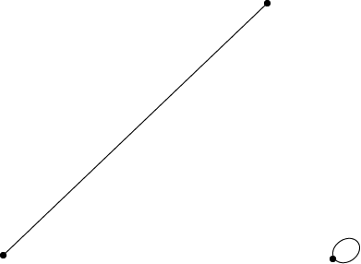
In Fig: we have V=2 and R=1. Thus 2+1-1=2
In Fig: we have V=1 and R=2. Thus 1+2-1=2
Hence, the basis of induction is verified.

Induction Step: Let us assume that the formula holds for connected planar graphs with K edges.
Let G be a graph with K+1 edge.
Firstly, we suppose that G contains no circuits. Now, take a vertex v and find a path starting at v. Since G is a circuit free, whenever we find an edge, we have a new vertex. At last, we will reach a vertex v with degree1. So we cannot move further as shown in fig:
Now remove vertex v and the corresponding edge incident on v. So, we are left with a graph G* having K edges as shown in fig:
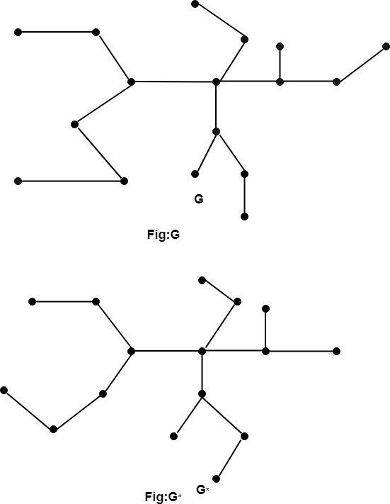
Hence, by inductive assumption, Euler's formula holds for G*.
Now, since G has one more edge than G*, one more vertex than G* with same number of regions as in G*. Hence, the formula also holds for G.
Secondly, we assume that G contains a circuit and e is an edge in the circuit shown in fig:
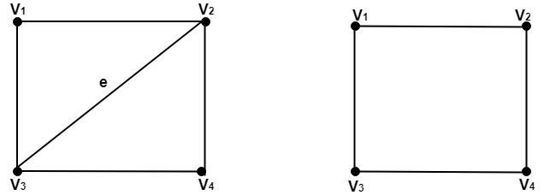
Now, as e is the part of a boundary for two regions. So, we only remove the edge, and we are left with graph G* having K edges.
Hence, by inductive assumption, Euler's formula holds for G*.
Now, since G has one more edge than G*, one more region than G* with same number of vertices as G*. Hence the formula also holds for G which , verifies the inductive steps and hence prove the theorem.

1. 4 Example:
Example 1: What is the number of regions in a connected planar simple graph with 20 vertices each with a degree of 3?

Solution: Sum of degrees of edges = 20 * 3 = 60. By handshaking theorem,
2e=60 which gives e=30.
By Euler’s theorem, the number of regions = e-v+2
which gives 12 regions.

An important result obtained by Euler’s formula is the following inequality –
Note –“If G is a connected planar graph with e edges and v vertices, where v≥3, then e≤3v-6 Also G cannot have a vertex of degree exceeding 5.”

Example 2: How many edges must have a planar graph if it defines 5 regions and has 6 nodes

Solution: By Euler’s Theorem
E-V+2=R
Here R=5 and V=6
So, E= R+V-2
= 5+6-2
=9
Therefore, it has 9 edges.
Example 3: For tetrahedron shape, prove the Euler’s Formula.
Solution: In a tetrahedron,
Number of faces, F = 4
Number of Vertices, V= 4
Number of Edges, E = 6
Thus, By Euler’s theorem ,
F+V-E= 4+4-6=2
Hence proved.

1.5 Some Areas of Application
- To prove a given graph as a planar graph, this formula is applicable.
- This formula is very useful to prove the connectivity of a graph.
- To find out the minimum colors required to color a given map, with the distinct color of adjoining regions, it is used.
Practice Questions
  - For cube shape, prove the Euler’s Formula.
  - Is it possible for a planar graph to have 6 vertices, 10 edges and 5 faces? Explain.
FAQ
Q.1 Can a polyhedron have 10 faces 20 edges and 15 vertex?
Ans: No, It can't have 10 faces , 20 edges, and 15 vertices as The formula i.e. Euler's formula isn't being satisfied.
Therefore, A polyhedron cannot have 10 faces, 20 edges, and 15 vertices.

Q.2 Who invented Euler's formula?
Ans: Leonhard Euler
The 18th-century Swiss mathematician Leonhard Euler (1707–1783) is among the most prolific and successful mathematicians in the history of the field. His seminal work had a profound impact in numerous areas of mathematics and he is widely credited for introducing and popularizing modern notation and terminology.

Summary
In this lecture, we have discussed about
- Euler’s Formula
- Proof of Euler’s Formula
- Examples of this formula being used
REFERENCES
Books
[1] Elements of Discrete Mathematics, (Second Edition) C. L. Liu, McGraw Hill, New Delhi, 2017
[2] G. Ronald, Knuth, Donald and Patashik Oren, concrete Mathematics: A Foundation for Computer Science", Addison-Wesley.
Websites
[1] https://www.geeksforgeeks.org/graph-theory-gq/
[2] https://www.javatpoint.com/regular-and-bipartite-graphs
Courses
[1] https://www.coursera.org/specializations/discrete-mathematics
[2] https://www.classcentral.com/course/swayam-discrete-mathematics-12929
Video Links
[1] https://youtu.be/5ywif1Zpeo4
[2] https://youtu.be/-9OUyo8NFZg

